# 

# PRODUCT SALES ANALYSIS

# Project Objectives:

* The project involves using IBM Cognos to analyze sales data and extract insights about top selling products, peak sales periods, and customer preferences.
* The objective is to
  + help businesses improve inventory management and
  + marketing strategies

by understanding sales trends and customer behavior.

* This project includes :
  + Defining analysis objectives
  + Collecting sales data
  + Designing relevant visualizations in IBM Cognos and
  + Deriving actionable insights.

# Design Thinking:

1. **Specific Insights**
   * The specific insights which will be extracted from the sale data includes
     + identifying top-selling products,
     + analyzing sales trends, and
     + understanding customer preferences.
2. **Data Collection:**
   * The data can be collected via datasets regarding ‘sales-stores product details’ in open source repositories such as ‘Kaggle’.
   * ‘Cleaning’ and ‘Pre-processing’ of dataset to remove the duplicate values, handle missing values and standardize the data formats.
   * Ensuring the data quality ,quantity and accuracy.
3. **Visualization Strategy:**
   * Before visualization, Depending on the complexity of the dataset, appropriate data model must be created. This involves defining relationships between different parts of data, creating calculated fields, conversion of data types such as one hot encoding (conversion of categorical to numerical data) and aggregating data to the required granularity.
   * Using IBM Cognos Framework Manager or Data modules to import and connect your prepared data to the Cognos environment.
   * Designing reports and dashboards in IBM Cognos that are tailored to the analysis objectives.
   * Different visualizing techniques such as :
     + Bar charts or Tables - for ‘Top-Selling-Products’
     + Line charts or time-series graphs - for ‘Peak Sales Periods’
     + Pie charts or heat maps – for ‘Customer Preferences’ is to be adopted .
4. **Actionable Insights:**
   * Using IBM Cognos features like filters, calculations, and drill-down capabilities to analyze the data interactively.
   * Applying statistical methods (such as univariate, bivariate and multivariate analysis) and algorithms to uncover patterns, correlations, and outliers.
   * If analyzing sales trends over time, use time-series analysis techniques. Decomposing time series data to separate trends, seasonality, and residuals.
   * For more advanced insights, future trends can be predicted using IBM Cognos Analytics

**Analysis Objectives:**

* + The specific insights which will be extracted from the sale data includes
    - identifying top-selling products,
    - analyzing sales trends, and
    - understanding customer preferences.
* And with the insights gained , it can be used for prediction purposes.

**DEVELOPMENT PHASES:**

The following methodologies can be adopted sequentially to achieve the specific insights mentioned above:

* + - Data Cleaning and Preprocessing : Prepare the dataset by handling missing values , outliers and data consistency.
    - Time-Series Analysis: Examine sales data over time to detect seasonality and trends.
    - Product Performance Analysis: Compare the performance of each product to determine the best-selling product.
    - Predictive Modeling: Develop predictive models to estimate sales for a specific period((eg) Predicting sales in the upcoming year – 2024)
    - Impact Assessment: Analyze the potential consequences of discontinuing one product.

**Various visualizing techniques such as :**

* + - Bar charts or Tables
    - Line charts or time-series graphs
    - Pie charts or heat maps can be used for analysis.

**Steps Involved using Cognos:**

* Interactive and customizable ‘Dashboards’ in IBM Cognos can be used for data exploration and data analysis.
* Multiple visualizations such as Bar charts, Pie charts, Line charts etc., for specific attributes for above kind of analyses (such as Time-Series Analysis, Product Performance Analysis) can be done in the created dashboard.
* Enhancement of visualizations can be done by customization options for colours, styles and labels.
* Using of Cognos tools for creating hierarchies and dimensions for complex reports
* ‘Predictive Modelling’ can be done in integration with other tools such as IBM SPSS Modeller, IBM Watson etc.
* ‘Filtering and drill-down’ capabilities can be used for creation of reports

Meta data modelling can be done for creating a unified view of data products.

Clustering algorithms can identify customer segments with distinct preferences. Recommendation systems can suggest products based on past customer behaviour.

**Data Collection :**

The data can be collected via dataset in open-source repository - ‘Kaggle’.

**(DATASET DESCRIPTION):**

* + - The ‘stats final’ dataset in ‘Kaggle repository’ contains detailed information about the product sales.
    - It deals with details of four products and has eight different attributes namely: Q1,Q2,Q3,Q4,S1,S2,S3,S4.
    - Q1- Total unit sales of product 1
    - Q2- Total unit sales of product 2
    - Q3- Total unit sales of product 3
    - Q4- Total unit sales of product 4
    - S1- Total revenue from product 1
    - S2- Total revenue from product 2
    - S3- Total revenue from product 3
    - S4- Total revenue from product 4

**a)Loading the Dataset:**

* It involves loading the dataset into the python noteebook( ‘statsfinal.csv’ – downloaded from [https://www.kaggle.com/datasets/ksabishek/product-sales-](https://www.kaggle.com/datasets/ksabishek/product-sales-data) [data](https://www.kaggle.com/datasets/ksabishek/product-sales-data))
* Now read the dataset and store it in the form of ‘Pandas DataFrame’.

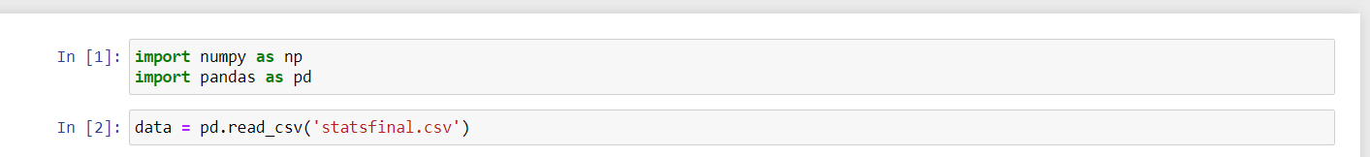

# b)Cleaning the dataset:

* Cleaning the data, also known as data preprocessing or data wrangling, is a crucial step in any data analytics project.
* It involves the process of identifying and handling issues or imperfections in the dataset to ensure that the data is of high quality, accurate, and ready for analysis.
* Here's a description of the data cleaning process in a data analytics project:

# Various stages of cleaning:

* 1. Data Inspection
  2. Handling Missing Values
  3. Handling Outliers

# Data Inspection:

* + - Started by examining the dataset to get an initial understanding of its structure and contents.
    - This includes checking the data types, column names, and the first few rows of data.

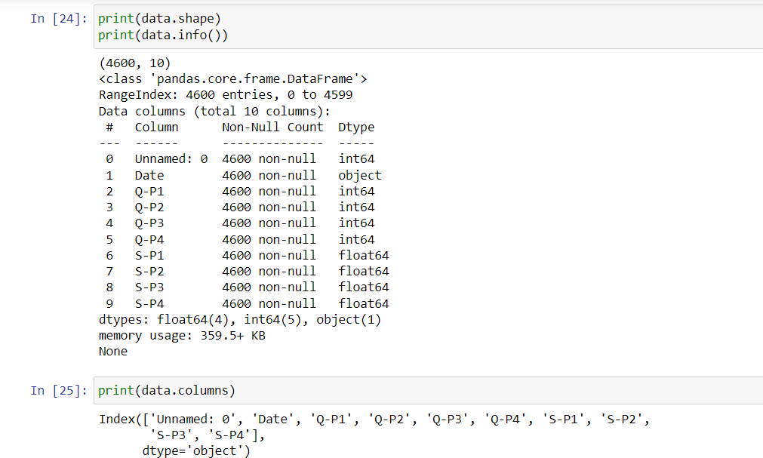

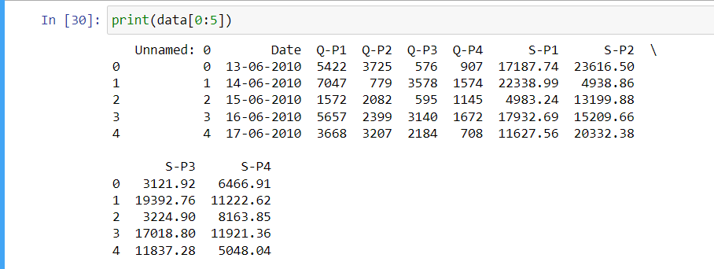

# 2.Handling Missing Values:

* + Identify and handle missing data points. Common strategies include:
  + Removing rows with missing values: If the missing data is minimal and the rows are not critical.
  + Imputing missing values: Replacing missing values with a specific value (e.g., mean, median, or mode of the column) or using predictive modelling.

# There were no null values or any missing values in the given dataset

# 3.Handling Outliers:

* + Detected and address outliers, which are data points significantly different from the majority.
  + Box plot was constructed to check outliers
  + But the dataset did not contain any outliers

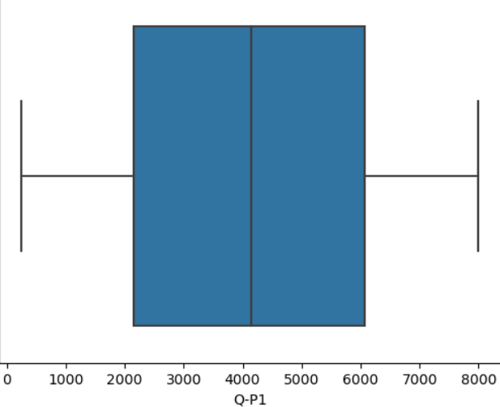

(Boxplot for the Q-P1 indicating no outliers)

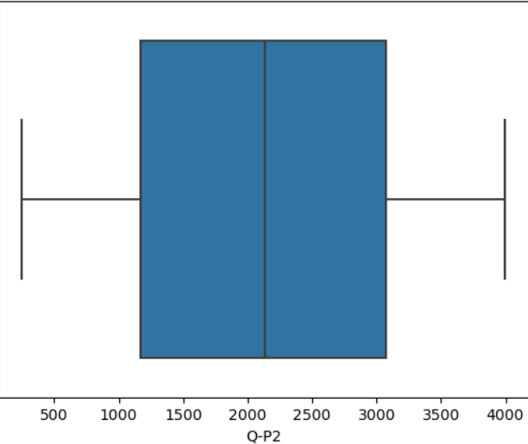

(Boxplot for Q-P2 – indicating no outlier)

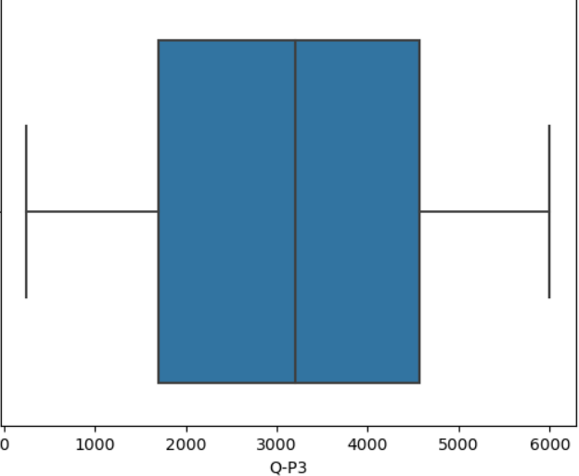

(Boxplot for Q-P3– indicating no outlier)

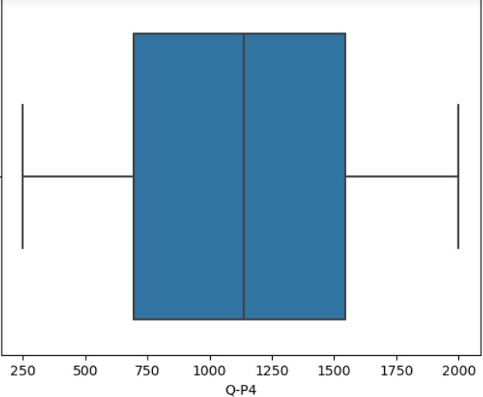

(Boxplot for Q-P4 – indicating no outlier)

# Data Exploration and Pre-Visualisation:

* At this stage, the dataset contained 8 columns with 4 columns the total selling cost of the respective four products and other 4 ,revenue from the each product .
* The ranges of each column and their corresponding paramaters are found.

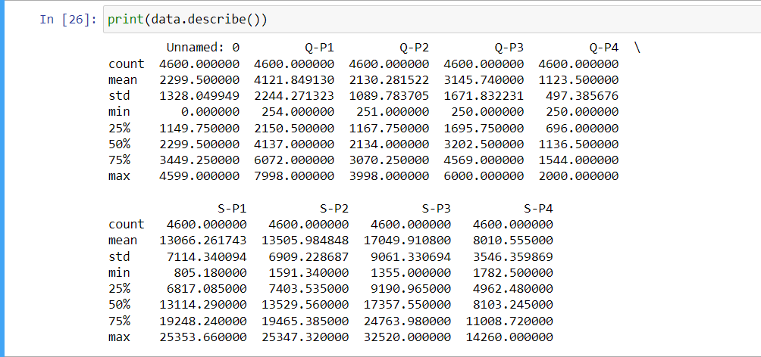

* From the ‘Date’ attribute of the dataset, years and month are obtained.
* From the year, the distribution of sales of each product for each year can be visualised.

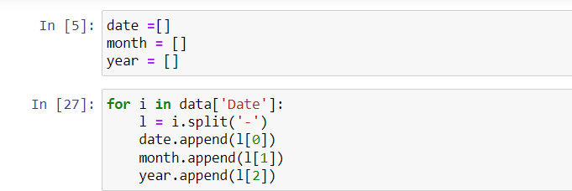

(Splitting the day , month and year from given dates)

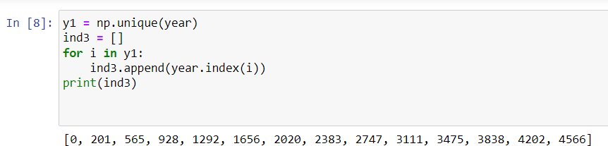

(Finding the starting index of each year in the dataset)

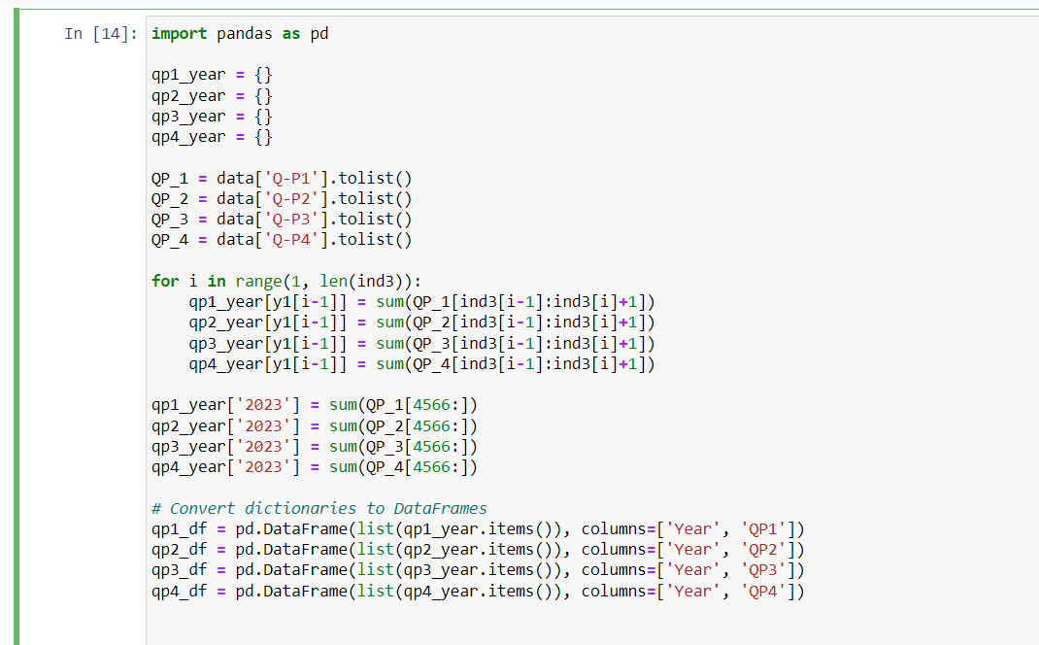

(Creating a dictionary for each product and filling it with the products sold in each year and converting it into a dataframe)

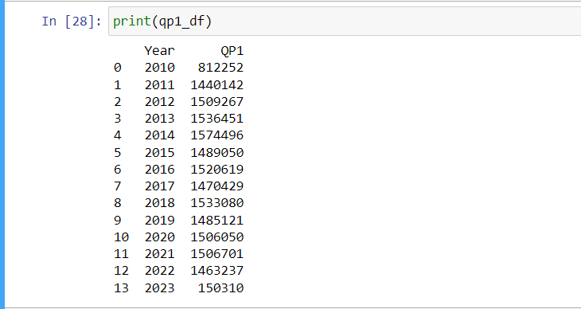

(Displaying the values)

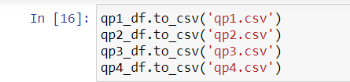

(Creating dataset from the dataframe)

* The process begins by parsing the date column to extract the month component.
* This is done for each row in the dataset.
* Next, the sales for each product are grouped by their respective months, and a count of sales for that month is maintained.
* Simultaneously, a counter for each month is incremented to keep track of how many years of data contain sales for that specific month.
* To calculate the average sales for each month, the total sales for that month is divided by the number of years for which sales data is available.
* This provides a fair comparison of monthly sales performance.
* And also sub-datasets are constructed for each product with months as x-attributes and sales as y-attributes.

# Visualization in Cognos Analytics:

* Creating dashboard in IBM Cognos Analytics.
* Uploading the datasets created in the previous step
* Plotting various graphs for each product.
* IBM provides various data visualization and business intelligence solutions that empower organizations to turn their data into actionable insights.
* Here's an introduction to IBM's data visualization tools and how they can benefit your data-driven initiatives:
* 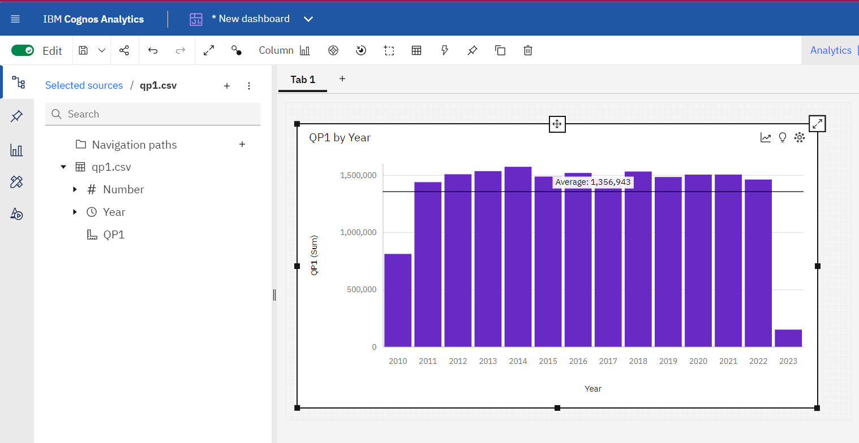 IBM offers a suite of data visualization tools that cater to different business needs, including IBM Cognos Analytics. These tools enabled us

(Barplot of the product sales of – Q-P1 with the year)

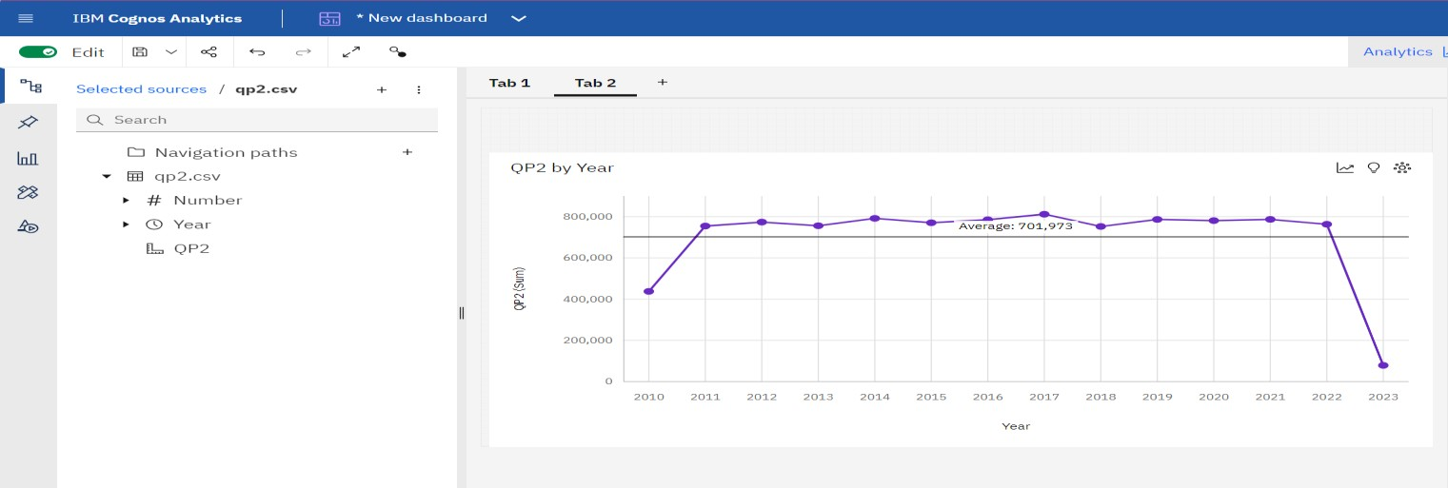

**(Lineplot of the product sales of – Q-P2 with the year)**

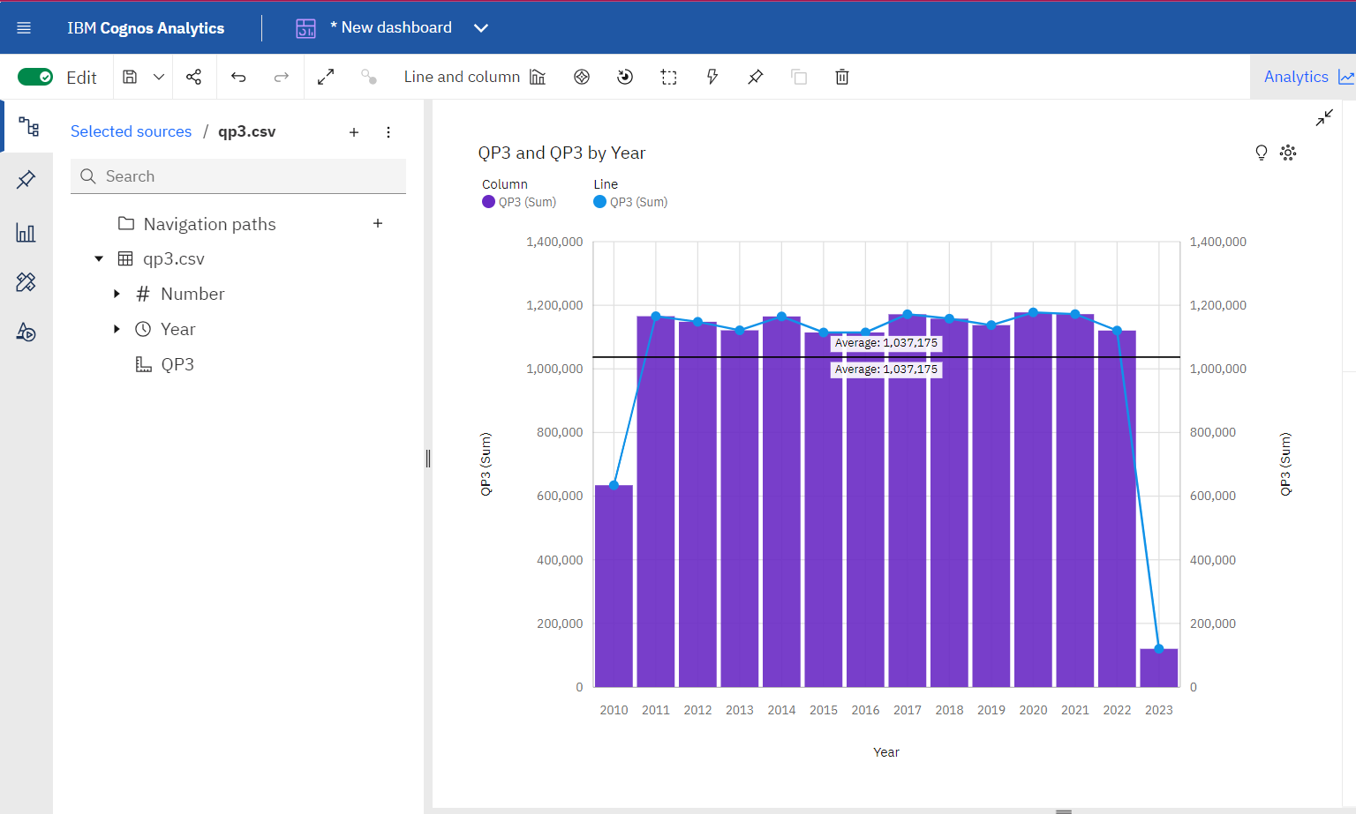

**(Barplot along with lineplot of the product – Q-P3 with the year)**

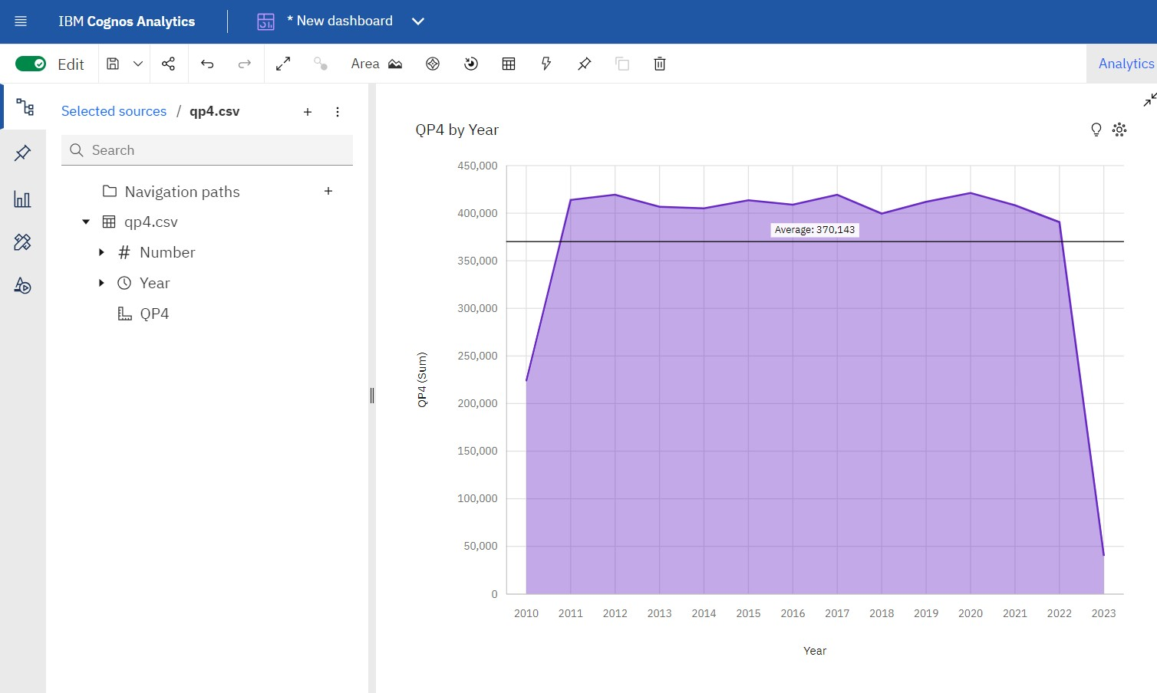

**(Area plot of the product – Q_P4 with the year)**

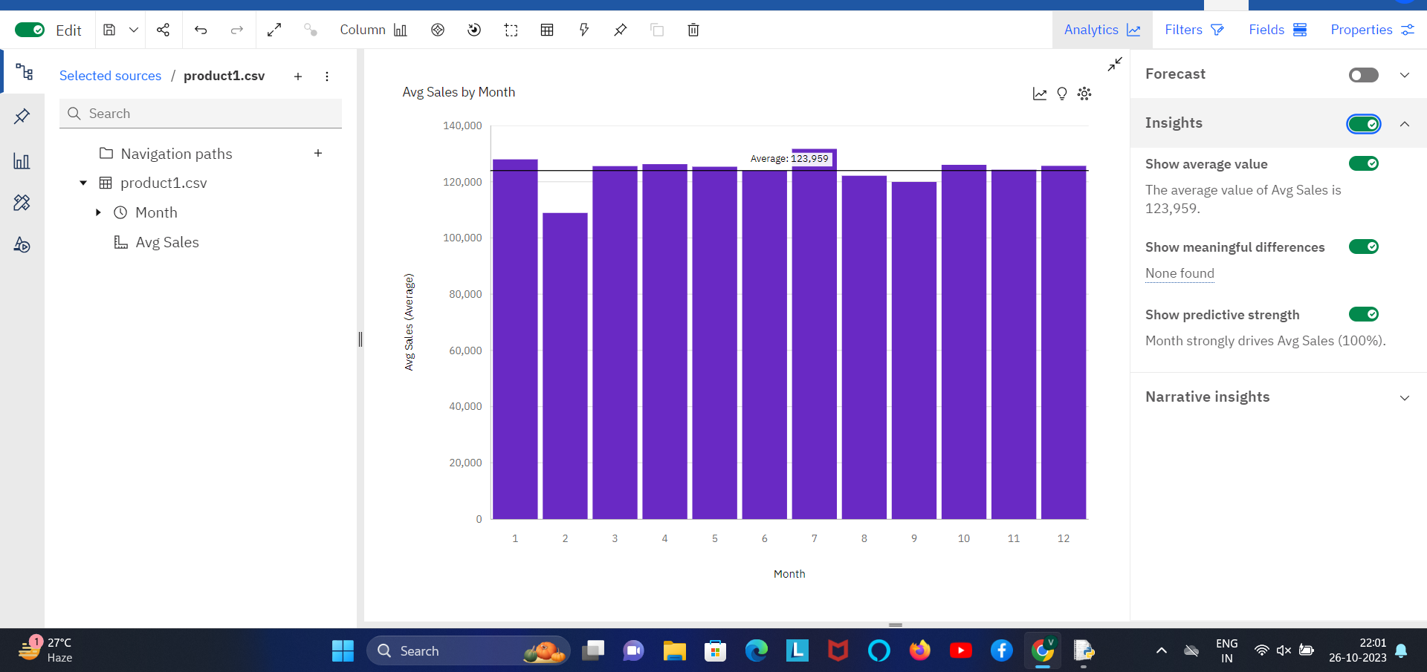

**(fig-1:Verical Bar Chart – Average Sales vs Months for Product-1)**

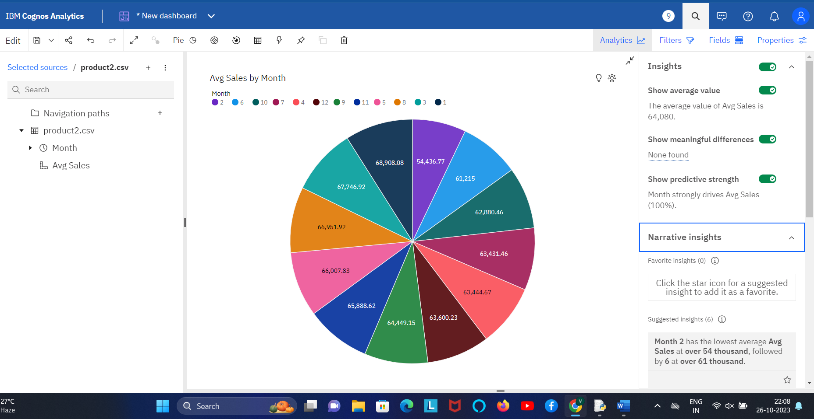

**(fig-2 : Pie-Chart describing the distribution of sales of product -2 in various months)**

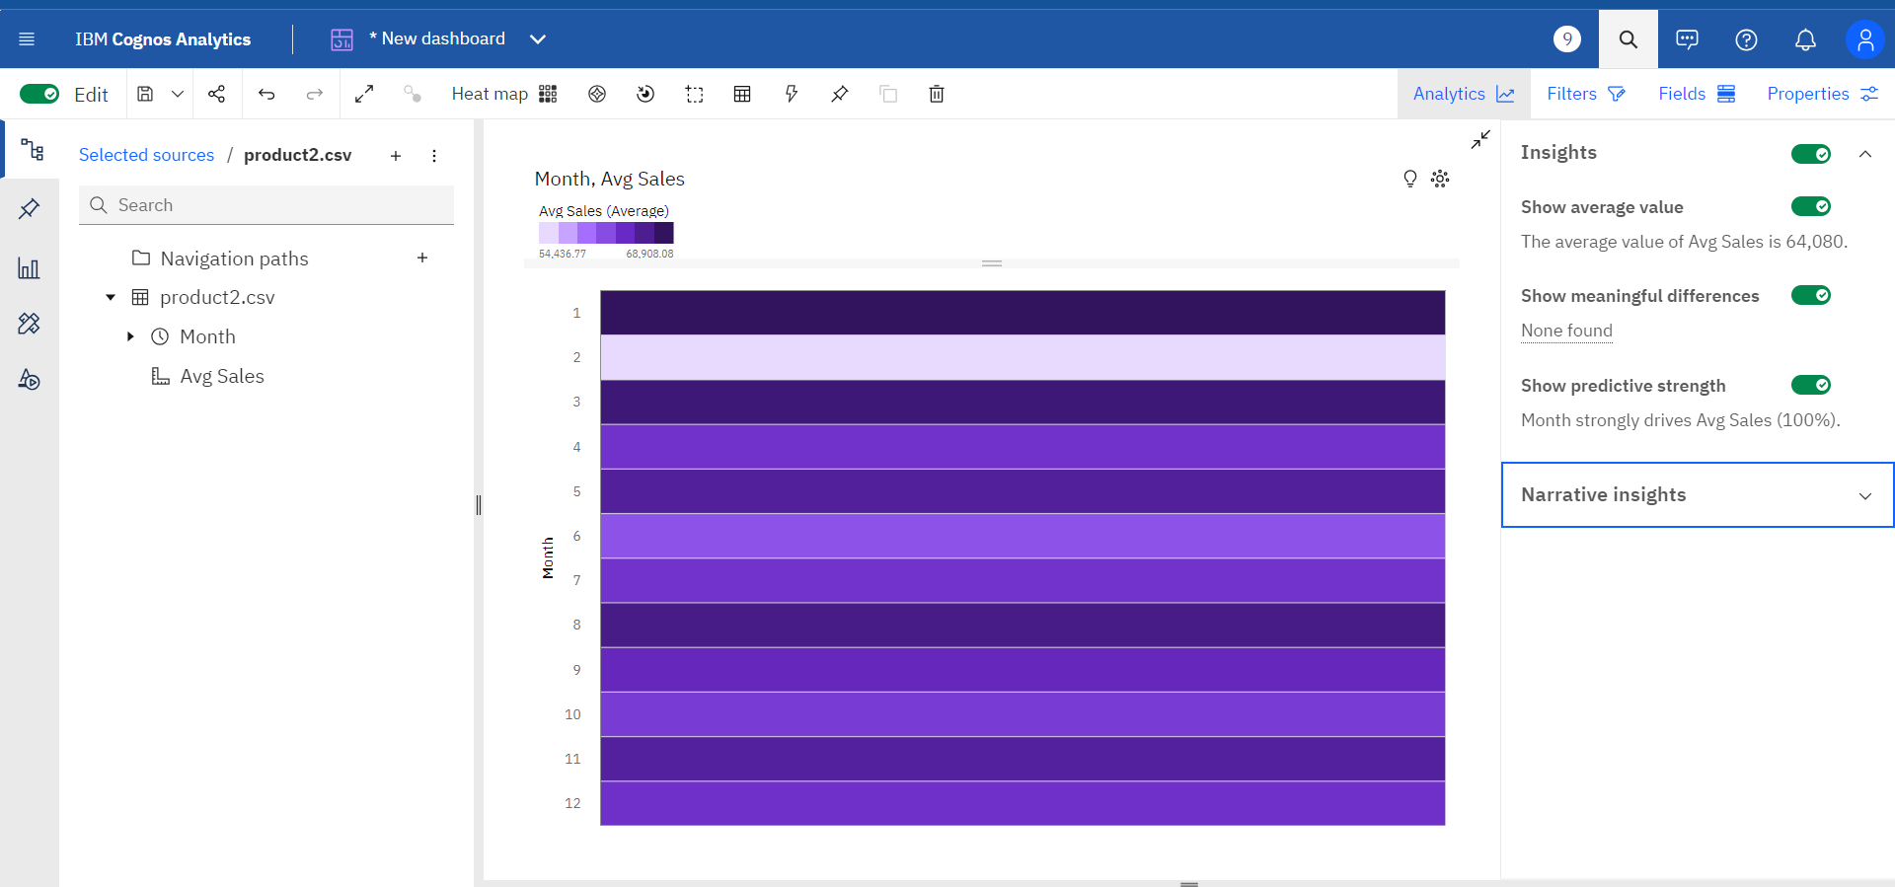

**(fig-3: Heat-Map denoting the intensity of sales of product-2 at different months )**

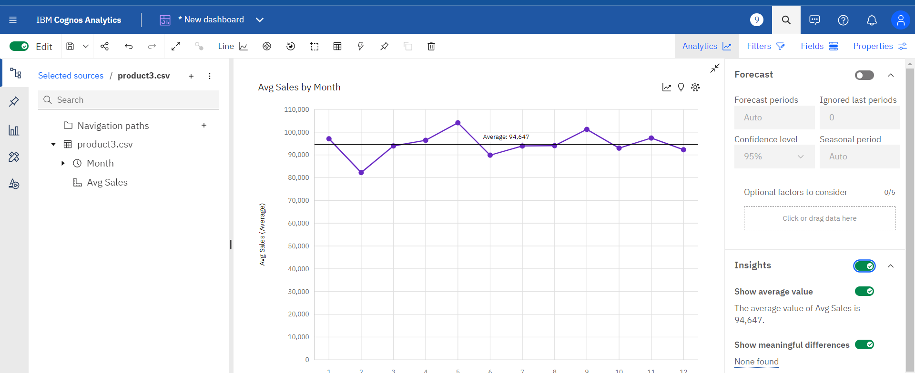

**(fig -4: LinePlot describing continuity and clear increase and decrease of sales of product-3 between months )**

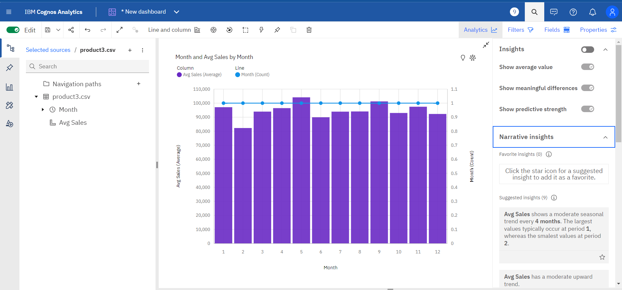

**(fig -5 : Barplot with column denoting average sales and line denoting the month)**

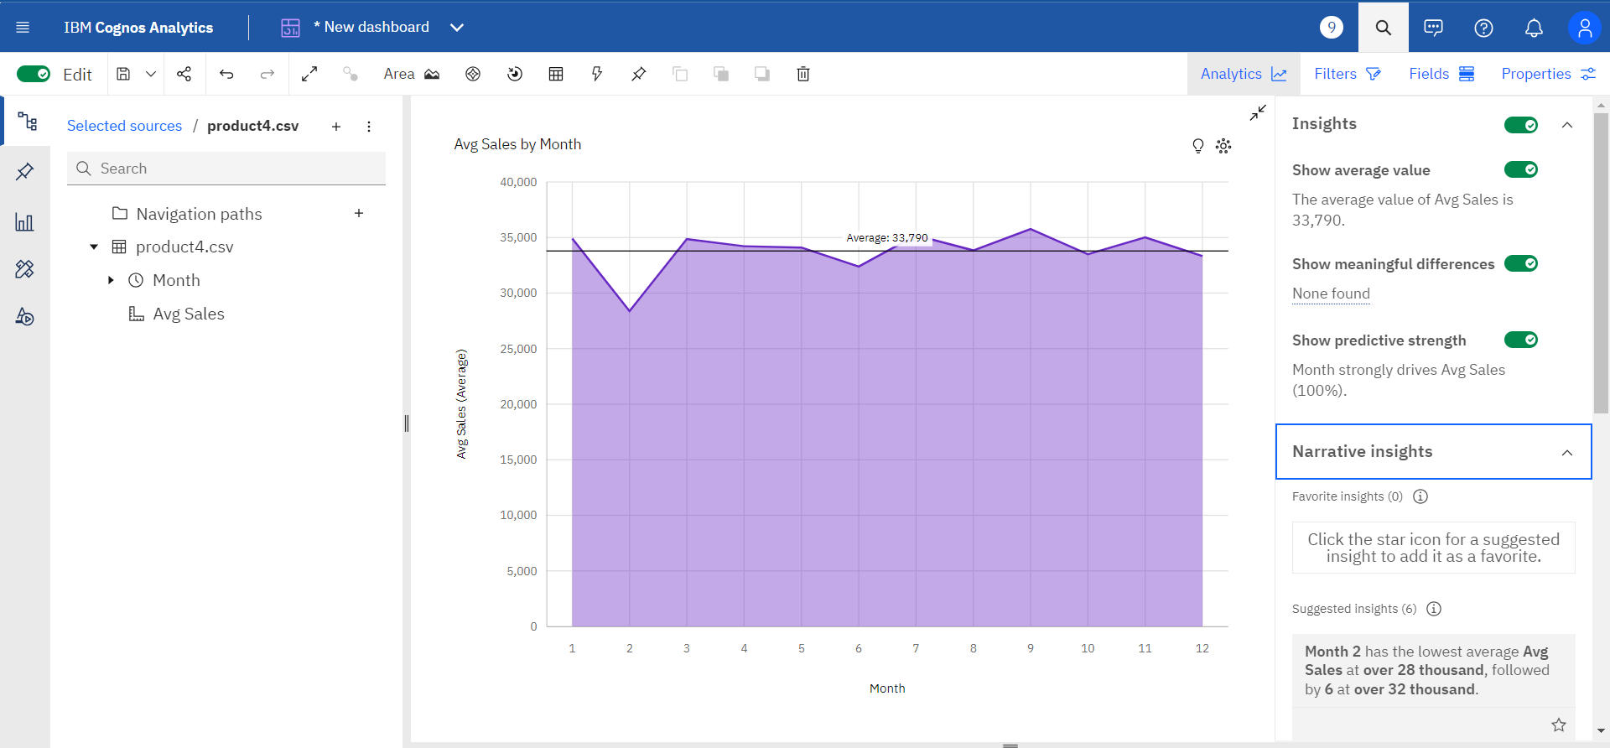

**(fig -6 : Areaplot for product-4 where column denoting average sales and line describes the average sales)**

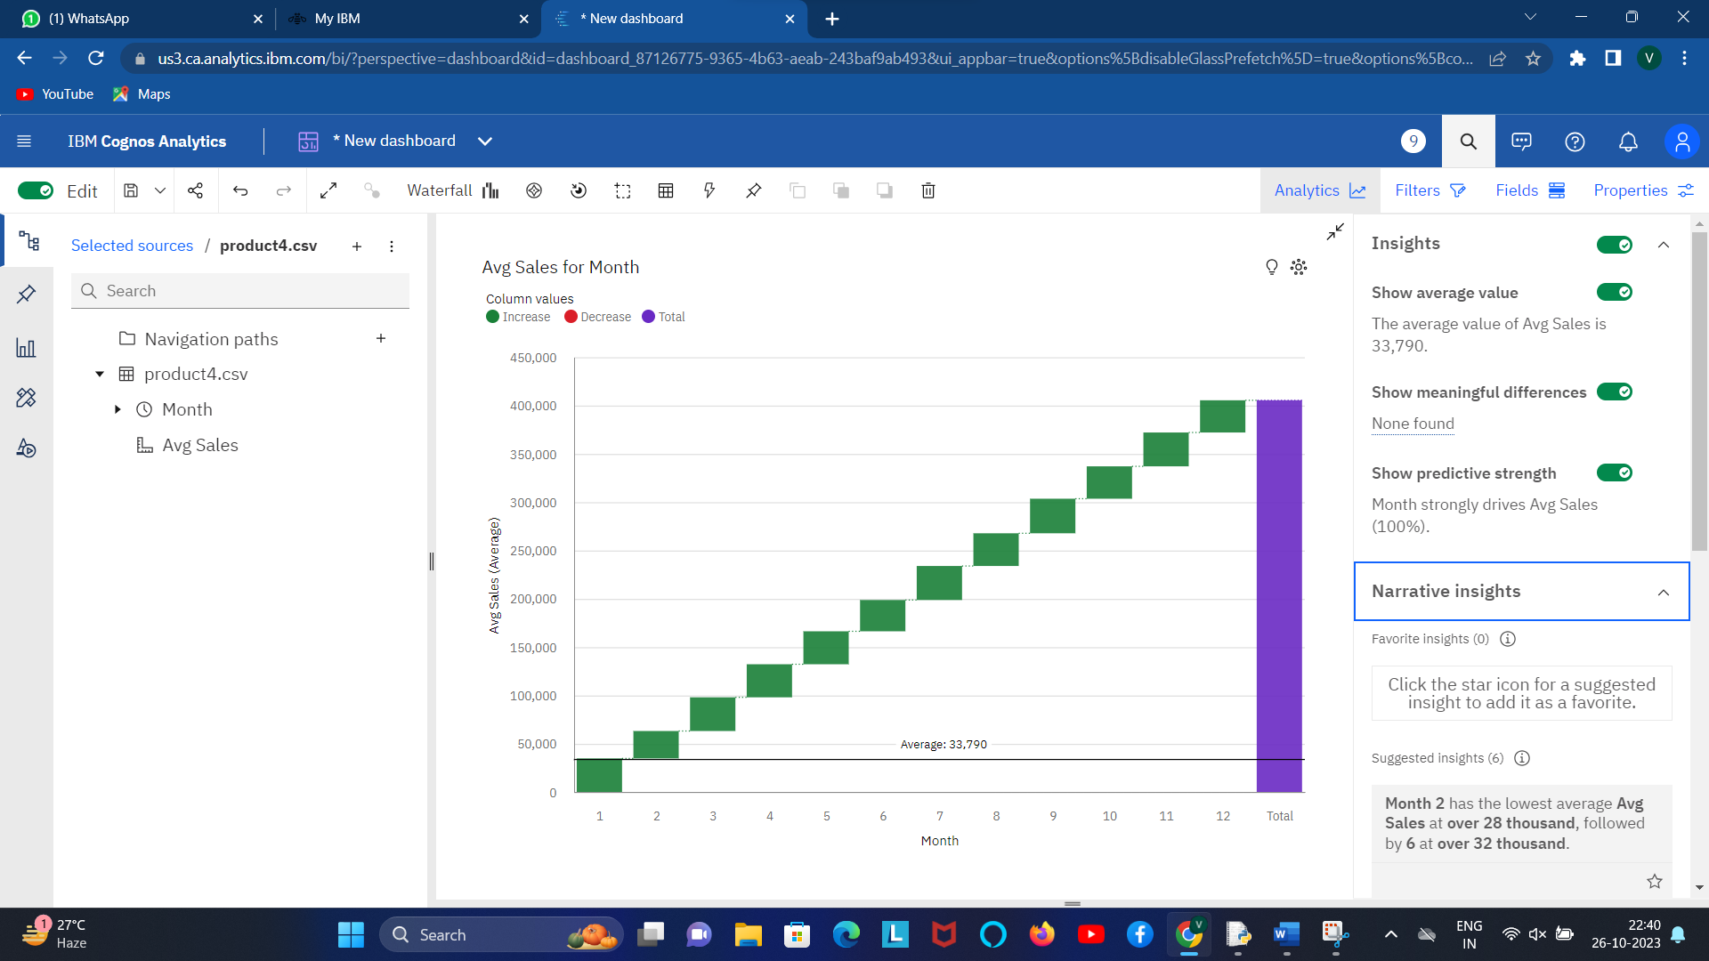

**(fig-7: Waterfall plot for product 4 where column describing the average sales for a month)**

**iii) Insights obtained from the visualizations**

* The insights obtained from data visualizations can be highly valuable for organizations across various domains. Here are some common insights that can be derived from data visualizations:

**PRODUCT 1:**

* Month 2 has the lowest average Avg Sales at nearly 109 thousand, followed by 9 at nearly 120 thousand.
* Month 7 has the highest average Avg Sales at nearly 132 thousand, followed by 1 at almost 128 thousand.Based on the current forecasting.
* Avg Sales may reach over 126 thousand by Month 15.Month strongly affects Avg Sales (100%).
* Over all months, the average of Avg Sales is nearly 124 thousand.The average values of Avg Sales range from nearly 109 thousand, occurring when Month is 2, to nearly 132 thousand, when Month is 7.

**PRODUCT 2:**

* Month 2 has the lowest average Avg Sales at over 54 thousand, followed by 6 at over 61 thousand.
* Month 1 has the highest average Avg Sales at almost 69 thousand, followed by 3 at almost 68 thousand.
* Based on the current forecasting, Avg Sales may reach over 64 thousand by Month 15Month strongly affects Avg Sales (100%).Across all months, the average of Avg Sales is over 64 thousand.
* The average values of Avg Sales range from over 54 thousand, occurring when Month is 2, to almost 69 thousand, when Month is 1.

**PRODUCT – 3:**

* Average Sales shows a moderate seasonal trend every 4 months. The largest values typically occur at period 1, whereas the smalest values at period 2.Avg Sales has a moderate upward trend.
* Month 2 has the lowest average Avg Sales at over 82 thousand, followed by 6 at almost 90 thousand.Month 5 has the highest average Avg Sales at over 104 thousand, followed by 9 at over 101 thousand.
* Based on the current forecasting, Avg Sales may reach over 95 thousand by Month 15.Month strongly affects Avg Sales (100%).Over all months, the average of Avg Sales is almost 95 thousand.
* The average values of Avg Sales range from over 82 thousand, occurring when Month is 2, to over 104 thousand, when Month is 5.The total number of results for Month, across all months, is 12.

**PRODUCT -4:**

* Month 2 has the lowest average Avg Sales at over 28 thousand, followed by 6 at over 32 thousand.
* Month 9 has the highest average Avg Sales at almost 36 thousand, followed by 7 at over 35 thousand.
* Based on the current forecasting, Avg Sales may reach over 35 thousand by Month 15.
* Month strongly affects Avg Sales (100%).Over all months, the average of Avg Sales is almost 34 thousand.
* The average values of Avg Sales range from over 28 thousand, occurring when Month is 2, to almost 36 thousand, when Month is 9.

**Based on the specific data provided for each product, here are tailored tips to improve profitability for each product:**

**Product 1:**

The lowest average sales occur in Month 2 and 9. Consider running targeted promotions or discounts during these months to boost sales. Focus on increasing sales in Month 15 to reach the expected sales of over 126 thousand. Consider analyzing customer behavior and preferences to tailor marketing strategies specifically for Month 7, which has the highest average sales.

**Product 2:**

Implement strategies to improve sales in Month 2 and 6, which have the lowest average sales. Capitalize on the high average sales in Month 1 and 3 by running special promotions or introducing new product variations. Continue efforts to maintain the average sales above 64 thousand as forecasted for Month 15.

**Product 3:**

Recognize the moderate seasonal trend every 4 months. Adjust inventory and marketing efforts accordingly. Concentrate on boosting sales in Month 2 and 6 while maintaining the strong performance in Month 5 and 9. Continue the upward sales trend, which has been observed, and aim to reach over 95 thousand by Month 15.

**Product 4:**

Enhance sales in Month 2 and 6, which have the lowest average sales. Maintain the high average sales in Month 9 and 7. Focus on reaching the forecasted average sales of over 35 thousand by Month 15. The common theme among these products is the need for targeted marketing and sales strategies to address specific months with lower sales. It's also important to maintain and build upon strong performance during high-sales months. Additionally, consider analyzing customer behavior and preferences to tailor strategies for each product.